(Approx. 1,339 words)

CEAInnovate!
By George Harding, Treasurer, Tucson Computer Society, AZ
December 2015 issue, TCS eJournal
www.aztcs.org
georgehardingbd (at) eartlink.net

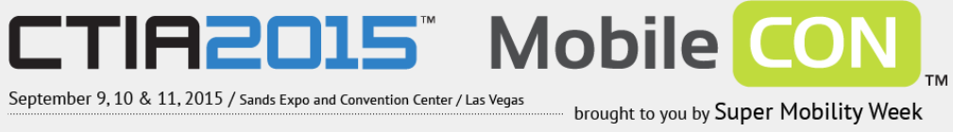
I attended a program put on by CEA, the parent organization that produces the Consumer Electronics Show, presented in Las Vegas the beginning week of January.

The program included a session called Technology Trends to Watch in 2015. It covered some of the hottest subjects today: 3-D printing, the Internet of Things (IoT), Big Data Analytics, Digital Health and Entertainment.

The panel on 3-D printing stated that the technology for home use is not mature and someone trying to use the reasonably priced models available today will have difficulty using them to do anything significant. The business versions, however, are very useful. The latest James Bond movie blew up a golden Aston Martin. It was created from a 3-D printer! It was actually a miniature, but was, nevertheless, an accurate replica of the car. The panel anticipate4s high growth in this product area over the next few years, as more uses are found for creative products.

The Internet of Things refers to the universe of applications which connect devices to the Internet resources without human interaction. There are many examples of this already in place: refrigerators advising you of the need to replace food; the many home situations that can be controlled by remote devices like smart phones; wearable technology to monitor and measure your health quality; GPS mapping in automobiles; self-driving cars. The current state of IoT has just begun and will expand dramatically in the future, according to the panel.

Big Data Analytics refers to the collection of usage data from you and others, in order to analyze and predict actions. This may be to identify the products you want more efficiently, to broaden product categories to better satisfy customers and increase sales and profits. Whether you know it or not, you are surrounded by Big Data collection and analysis. Every time you use a credit card, the data associated with the purchase goes to combine with other data to better serve our needs and the needs of business. An associated issue is that of privacy. There is as yet no consensus about whether Big Data is good or bad, whether it should be allowed or controlled in some way.

Digital Health is also known as Wearable Tech. This is a fast developing field, with quite a large number of products already on the market. The continued development will be in making products do more and do it better. It may go from the ability to track and measure health and fitness to actual diagnosis of disease.

Entertainment is big now, of course, but it shows no signs of slowing down. The personal game devices and the online gaming continue their rapid growth. What is just starting its big growth is the streaming of movies and shows. The trend is driven by the growing reluctance to be tied to a television set for one’s entertainment.

It will be very interesting to see how these areas develop and grow over the next decade.

Tech Armor case for iPhone6
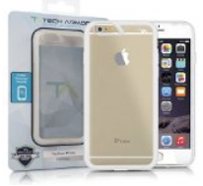
There are many cases available for the new iPhones. One of the best is Tech Armor’s case for iPhone6 (there’s also one for the iPhone6 Plus).

The new iPhones are different in several ways: thinner, larger and with screen that is rounded at the edges. The Tech Armor case handles all of these.

Not only is it attractive, being a steel gray color, but it is tough enough to protect your phone from bumps, drops, scratches and knocks. The case has a slightly rough surface, making it easy to grasp and hold.

The cutouts for the various buttons are well done, making it easy to press the buttons when needed.

The back is clear plastic, hard and protective of the iPhone back. The case does not come with a screen protector, but Tech Armor has that, too.

The case comes with a lifetime warranty and is reasonably priced.

About: Tech Armor case for iPhone6
Vendor: Tech Armor
www.techarmor.com
Price: $15, screen $7

Price: $15, screen $7

Ventev
This company produces wireless infrastructure products and mobile accessories. I was provided with several of the mobile accessories to test.

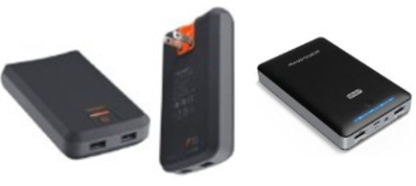
Powercell 6000. This external battery can be easily charged in any wall socket. The back of the charger has two prongs which fit the wall socket and fold into the charger case. You can charge one or two mobile devices with the built-in USB sockets, one providing 1 amp output at 5 watts, the other 2 .1 amps at 10 watts . The higher capacity output can be used for a tablet, or a smart phone. In fact, you can charge two mobile devices at the same time, if needed. Price $75.

Dashport r900. This is a charger, too, but designed to be used in your car. It plugs into the power outlet in the car’s dash and provides power whether or not you are near an outlet. It comes with a cable for standard USB connection and also micro-USB. Price $40.

Chargesync cables. There are several versions of this product, but each is designed to connect your mobile device to its charger or to another type of charger. What’s really great about these cables is that they are flat, which means that they do not get tangled up like the round ones. They come in different colors, too. Whether you have an iPhone with 30-pin connection or one of the newer iPhone 5 or 6 cables, or even something else, you’ll be able to find one of these cables for you.

Price: $15 - $25
About: Ventev
www.Ventev.com

WeMo by Belkin
We’ve known Belkin for many years for electronic gear, but they recently opened a new product area for exploration, capitalizing on the use of the Internet to connect disparate things, the so-called IoT (Internet of Things).

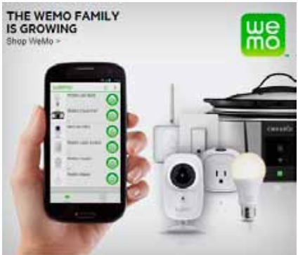
I received their WeMo LED Lighting Starter Set for review. It contains two light bulbs and a Link device, plus a set of very brief instructions.

The light bulbs are equivalent in illumination to 60 watt tungsten bulbs. We have been urged to replace tungsten bulbs with CFL (compact flash light) bulbs, with the incentive that illumination is equivalent but electrical usage is much lower. The bulbs in this kit are LED and go further in reducing electrical usage.

The bulbs look like what we’re used to, but have some wizardry inside to allow connectivity through the Internet.

So, what does the kit do for you? It allows you to control two light fixtures separately and to turn each off or on at specified times, on specified days.

The procedure is to plug the Link into a wall socket. An LED comes on to tell you that it’s connected. Next, you replace an existing bulb in a lamp or other fixture with one of the WeMo bulbs. You can use both bulbs in the same fixture (a chandelier, say) or in two separate fixtures. Each is controlled separately.

Next you download the WeMo app. There is one for Apple as well as Android. You next connect through the app to the WeMo network, then to your home or office network. Once this is done, the app searches for devices. When it finds the bulbs, it stores them and takes you to a page where you can set up your rules.

The rules involve On time, Off time and day(s) of the week. There is also an Away From Home setting, which is different from the standard setting. One other feature is the ability to fade in or out when the bulb turns on or off.

With the bulbs and the app, you have control over your lighting, no matter where you are, provided you have Wi-Fi, 3G or 4G service.

Belkin has other devices in the WeMo line: Light Switch, Switch/Motion, Crock Pot, Holmes Heater, Holmes Humidifier, Mr. Coffee and Holmes air Purifier.

About: WeMo
Vendor: Belkin
www.belkin.com/us
Price: $100, additional bulbs $30

